RUSTIC SAVORY CRISPY WAFFLES
Crisp and aromatic accompaniment to chicken for brunch or with your favorite topping
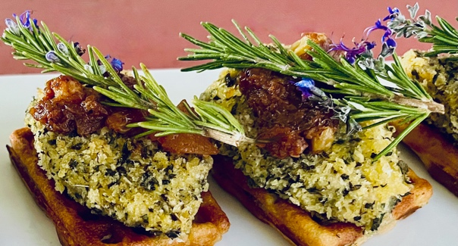
PREP TIME: 10 minutes
COOK TIME: 20 minutes
TOTAL TIME: 30 minutes
YIELD: 6 large waffles

INGREDIENTS
1 3/4 cups unbleached flour
1 Tbsp baking powder
1 pouch GC Napa Valley Natural Provence Herb Blend
1/2 cup GC Napa Valley Buttery Extra Virgin Olive Oil
1/4 tsp. GC Napa Valley Rosemary Sea Salt
1/2 cup GC Napa Valley Fall Harvest Honey, warmed (can use rosemary, marjoram, or plain honey)
2 large eggs- separated
1 3/4 cups buttermilk TIP If you don’t have buttermilk on hand, make on your own. Put one tbsp of white vinegar or lemon juice in a one-cup measuring cup and fill the rest up with milk to the one-cup line.

TO PREPARE
- In a medium mixing bowl, combine dry ingredients: flour, baking powder, Rosemary Sea Salt, and sugar, Provence Herb Blend and stir to combine.
- Crack eggs and separate the egg whites from the egg yolks into a separate bowl.
TIP: Do not get any egg yolk into the egg whites or they will not beat into a stiff peak.
- With a hand or counter-top mixer, whip the egg whites until they form stiff peaks.
- Make a well in the center of the dry ingredients and add the egg yolks, Buttery Extra Virgin Olive Oil, warmed Fall Harvest Honey and buttermilk. Whisk into a semi-thin batter with few lumps remaining.
- Gently fold stiff egg whites into the batter- Egg whites create fluffy waffles, so don’t deflate the air from the batter. Use a rubber spatula to scoop under the batter, then fold batter over -repeat until mixed in. Avoid over-mixing.
- MAKE WAFFLES EXTRA CRISPY Pour the batter into waffle iron. If your waffle maker has heat settings, set to “dark” or the highest temperature or just cook them for a bit longer than the cycle says. Be careful not to burn them. When the waffle is crisp, remove and place on a wire rack to cool. DO NOT stack waffles once they’re done cooking! This traps steam between them, causing them to get moist and soggy. To keep waffles warm and make them extra crispy on the outside, heat the oven to 250 degrees F. Place waffles spaced 1” between them on a wire rack for 5 to 10 minutes.
- Repeat with remaining batter.

TO SERVE
This recipe is ideal for a variety of waffle topping- maple syrup, honey drizzled, or chutney topped roasted herb chicken breast (shown in picture), thick cut bacon or honey glazed ham .

SHOPPING LIST & ITEMS FROM YOUR PANTRY INCLUDING ITEMS FROM PREVIOUS SHIPMENT
Prefer organic, farmers market, garden grown, GMO-hormone-antibiotic-nitrate free products
Unbleached Flour
Baking Powder
GC Napa Valley Rosemary Sea Salt
2 large eggs
1 qt buttermilk
Substitute honey options: rosemary, marjoram, or plain

GC NAPA VALLEY PRODUCTS IN CURRENT SHIPMENT
GC Napa Valley Natural Provence Herb Blend .8 oz Pouch
GC Napa Valley Buttery Extra Virgin Olive Oil 250 ml
GC Napa Valley Fall Harvest Honey 8oz

