WINE COUNTRY GARDEN BEES KNEES COCKTAIL
A Napa Valley twist to a classic Prohibition era cocktail
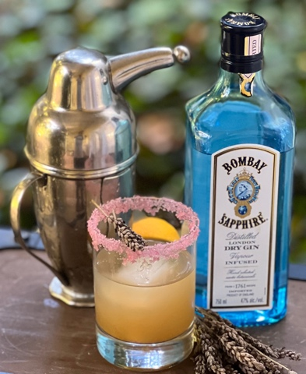
Gin, fresh lemon juice, and simple syrup create this cocktail. Our version features O’Connell Family Estate Vineyard Garden fall harvests to create GC Napa Valley Rim Seasoning: Pomegranate Sugar, and GC Napa Valley guava sugar to add layers of flavor. It is traditionally served in a coupe glass, but Gabrielle prefers a rocks tumbler over ice for brunch with an extra-large ice cube. The cocktail’s name comes from Prohibition-era slang meaning "the best”. Enjoy!

PREP TIME: 5 minutes
TOTAL TIME: 10 minutes
SERVES: 2

SPECIAL EQUIPMENT:
Cocktail shaker
Jigger or shot glass- a unit of measurement in cocktail recipes. The standard size is 1.5 oz.
On the Rocks Stemless Cocktail Tumbler
Extra-large cube tray. TIP large cubes look dramatic and melt slower to dilute your drink perfectly.

INGREDIENTS: for 1 cocktail served in On the Rocks Stemless Cocktail Tumbler
1/2 cup reg sized ice cubes
1 Extra-large ice cube Substitute 4 regular sized ice cubes
4 oz gin
1/2 cup freshly squeezed lemon juice
1 lemon wedge
2/3 cup GC Napa Valley Natural Guava Sugar
2/3 cup warm water
2 2” Lavender sprig- fresh or dried
¼ cup Tbsp Rim Seasoning: Pomegranate Sugar

TO PREPARE
Make guava simple syrup
- Mix the Guava Sugar with the warm water in a small saucepan over low heat.
- Stir and cook until the sugar dissolves. Remove from heat and transfer to a heat resistant glass container. Reserve
Prepare glass rim
Use a tumbler or coup glass
- Rub 1 Lemon wedge around glass rim to wet the edge.
- Pour Rim Seasoning Pomegranate Sugar onto a small flat plate and push down to spread out.
- Turn glass upside-down and twist back and forth into the sugar until well coated
- Put the gin, freshly squeezed lemon juice, guava syrup, ½ cup regular sized ice cubes into cocktail shaker. Shake well. Serve immediately

TO SERVE
Place ice cube(s) into the prepared pomegranate sugar rimed glass. Carefully pour over ice cube(s) avoiding touching the rim sugar. Garnish- add a Lavender sprig or lemon slice floating in the cocktail.

SHOPPING LIST & ITEMS FROM YOUR PANTRY
Prefer organic, farmers market, garden grown, GMO-hormone-antibiotic-nitrate free products
bottle gin- select a premium quality such as Tanqueray, Beefeaters, or your favorite artisan brand
2 lemons
Ice cubes

GC NAPA VALLEY PRODUCTS IN CURRENT SHIPMENT
GC Napa Valley Natural Pomegranate Sugar
GC Napa Valley Natural Guava Sugar
Lavender sprig

