SQUEEZED GRAPEFRUIT TARRAGON VINAIGRETTE
This dressing loves vegetables
A 5 Step Recipe
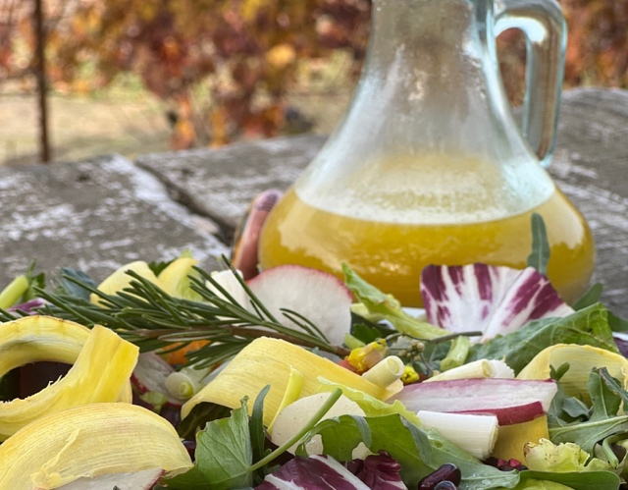
PREP TIME: 10 minutes
COOK TIME: 1 minutes
TOTAL TIME: 11 minutes
YIELD: 2 1/4 cups

INGREDIENTS
¾ cup GC Napa Valley cider Vinegar
½ cup grapefruit juice from 2 yellow grapefruits
1 cup GC Napa Valley Natural Blood Orange Olive Oil
½ tsp GC Napa Valley Natural Lemon Tellicherry Pepper
½ tsp. GC Napa Valley Chardonnay Finishing Sea Salt
1 Tbsp GC Napa Valley Natural Orange Infused Honey
(can substitute Lavender Honey)
2 Tbsp shallot, minced
1 tsp. Dijon mustard
2 Tbsp fresh tarragon leaves

TO PREPARE
- Heat over low heat Orange Infused Honey with cider vinegar until just warmed. Pour into medium sized bowl
- Squeeze juice from 2 white grapefruits to make ½ cup grapefruit juice
- Pull leaves from stems of fresh tarragon
- Add grapefruit juice, tarragon and all remaining ingredients all ingredients and whisk together until smooth.

TO SERVE
Drizzle over prepared salad.

WINE PAIRING
Citrus is easy on wine, so pair any salad made with this DRESSING with Pietro Family Cellars Field Blend Red Wine, California
or 2018 Pietro Family Cellars Sauvignon Blanc Napa Valley

SHOPPING LIST & ITEMS FROM YOUR PANTRY
Prefer organic, farmers market, garden grown, GMO-hormone-antibiotic-nitrate free products
1 shallot
2 yellow grapefruits
cider vinegar
Dijon mustard
1 bunch fresh tarragon
GC Napa Valley Chardonnay Finishing Sea Salt
GC Napa Valley Natural Lemon Tellicherry Pepper
GC Napa Valley Natural Orange Infused Honey

GC NAPA VALLEY PRODUCTS IN CURRENT SHIPMENT
GC Napa Valley Natural Blood Orange Olive Oil
GC Napa Valley Natural Culinary Lavender Honey 8 oz jar

