SHAVED FALL VEGETABLE SALAD WITH FRESHLY SQUEEZED GRAPEFRUIT TARRAGON VINAIGRETTE
A feast of color for the eye and texture for the tastebuds.
Crunchy greens, sumptuous Marinated Feta Cubes and the fresh citrus-based vinaigrette deliver layers of seasonal flavors.

PREP TIME: 10 minutes
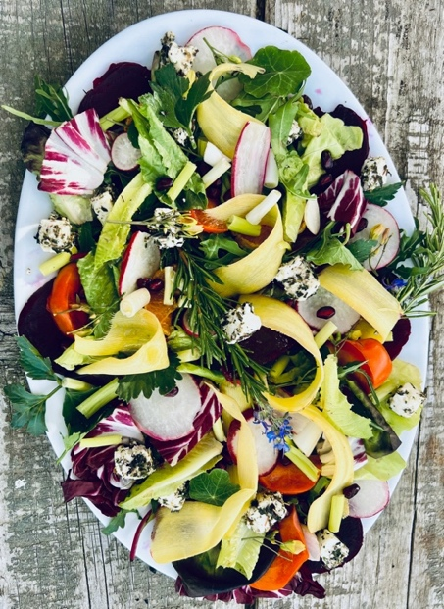
COOK TIME: 20 minutes
TOTAL TIME: 30 minutes
SERVES 4-6

INGREDIENTS
3 carrots trimmed and washed- heirloom or standard orange
1 Fuyu persimmon sliced in 1/2”thick wedges
3 small beets of assorted colors; leaves removed and washed
1 head radicchio
1 box prewashed mix of baby arugulas and assorted greens
4 large radishes trimmed, washed
½ cup pomegranate seeds (arils)- purchase seeds or deseed 1 pomegranate
3 roughly chopped green scallions
3 tangerines, peeled and sliced into ¼ “thick rounds
½ cup pine nuts
15 Herb Marinated Feta Cheese Cubes -see recipe
½ cup Grapefruit Tarragon Vinaigrette-see recipe
½ tsp. GC Napa Valley Chardonnay Finishing Sea Salt
½ tsp. GC Napa Valley Lemon Tellicherry Pepper

TO PREPARE
Prep each salad component and put into separate bowl until ready to arrange salad:
- Peel skin of 3 carrots and shave into long strips using a vegetable peeler
- Place beets into medium saucepan. Cover with water and cook until soft -about 20 minutes. Gently peel off skin. Carefully slice into ¼ “ thick rounds. Put each color on a separate plate. Watch out- the juice stains. Wash hands when finished.
- Cut radishes into ¼” slices.
- Remove seeds from 1 pomegranate. Pick out any bitter white flesh. Watch out again- the juice stains.
- Wash and dry baby arugula and assorted greens salad mix. Note: We suggest rewashing greens- just in case…
- Remove seeds from tangerine slices
- Pull leaves from ½ head of radicchio and tear into 2”pieces.
- Prepare Herb Marinated Feta Cubes and Grapefruit Tarragon Vinaigrette and set aside.

TO SERVE
Place in a large bowl and very gently toss with hands to mix (without dressing): arugula and assorted greens, radicchio, Fuyu persimmon sections, chopped green scallions, and slices of radishes. Sprinkle the mix over a large platter. Arrange over the mix: beet slices, carrot shaving, Herb Marinated Feta Cubes, and tangerine slices. Sprinkle top with pine nuts and pomegranate seeds. Drizzle Grapefruit Tarragon Vinaigrette over arranged salad. Season with Chardonnay Finishing Sea Salt and Lemon Tellicherry Pepper. Present your masterpiece! Serve from the platter.

SHOPPING LIST & ITEMS FROM YOUR PANTRY
Prefer organic, farmers market, garden grown, GMO-hormone-antibiotic-nitrate free products
3 carrots -yellow
1 head radicchio
4 large radishes
3 green scallions
3 tangerines
1 Fuyu persimmon

1 box prewashed mix of baby arugulas and assorted greens
4 small beets, washed- assorted colors- yellow, variegated red, purple
1 whole fresh pomegranate or pomegranate seeds (arils)
GC Napa Valley Chardonnay Finishing Sea Salt
¼ lb. pine nuts
GC Napa Valley Lemon Tellicherry Pepper
GC NAPA VALLEY PRODUCTS PROVIDED IN CURRENT SHIPMENT

FINISHED INGREDIENTS FROM CURRENT SHIPMENT RECIPES
Herb Marinated Feta Cheese Cubes
Grapefruit Tarragon Vinaigrette

WINE PAIRING:
Pietro Family Cellars Field Blend Red Wine, California

