HERB MARINATED FETA CHEESE CUBES
Great accent for salads and on Charcuterie board
A 5 STEP RECIPE
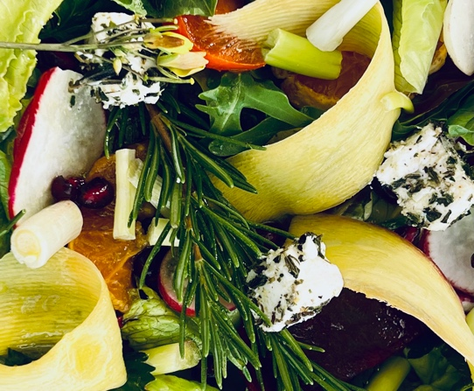
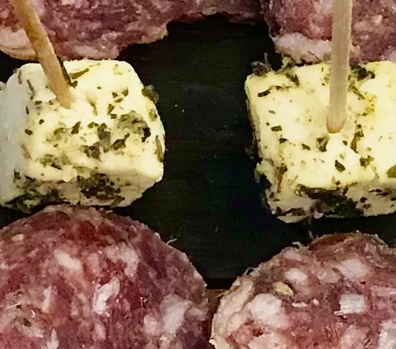

PREP TIME: 5 minutes
TOTAL TIME: 5 minutes
YIELD: 1 PINT OF ¾ ‘’SQUARES

CHARCUTERIE ACCENT
SALAD INGREDIENT

INGREDIENTS
1 container Feta Cheese
1 Tbsp GC Napa Valley Mediterranean Herb Blend
1 tsp. GC Napa Valley Lavender Tellicherry Pepper
1/2 cup GC Napa Valley Basil Olive Oil

TO PREPARE
- Drain water/brine from feta cheese. Remove feta from container onto a cutting board. Feta often comes in large slices. Be careful not to break the cheese. Dry any liquid with paper towel. The less liquid the better result. Cut cheese into 1/2” cubes.
- Sprinkle Mediterranean Herb Blend and Lavender Tellicherry Pepper over cheese cubes. Carefully turn to coat all sides
- Return Feta cubes to the container they were purchased in and pour 1/2 Basil Olive Oil over the cubes. Put lid back on and gently turn container side to side to coat cubes with oil.

TO SERVE
Use HERB MARINATED FETA CHEESE CUBES in a salad or as part of a charcuterie platter, also delicious on a toothpick with 2 cherry tomatoes and 1 FETA CHEESE CUBE.

SHOPPING LIST & ITEMS FROM YOUR PANTRY INCLUDING ITEMS FROM PREVIOUS SHIPMENT
Prefer organic, farmers market, garden grown, and GMO, hormone-antibiotic-nitrate free products
1 container Feta Cheese
GC Napa Valley Lavender Tellicherry Pepper

GC NAPA VALLEY PRODUCTS IN CURRENT SHIPMENT
GC Napa Valley Basil Olive Oil 250ml
GC Napa Valley Mediterranean Herb Blend.8 oz pouch

WINE PAIRING
Pietro Family Cellars Field Blend Red Wine

