GUAVA-POMMEGRANATE SAUVIGNON BLANC POACHED PEAR
A light seasonal winter desert for a perfect ending to a hearty meal
A 5 STEP RECIPE

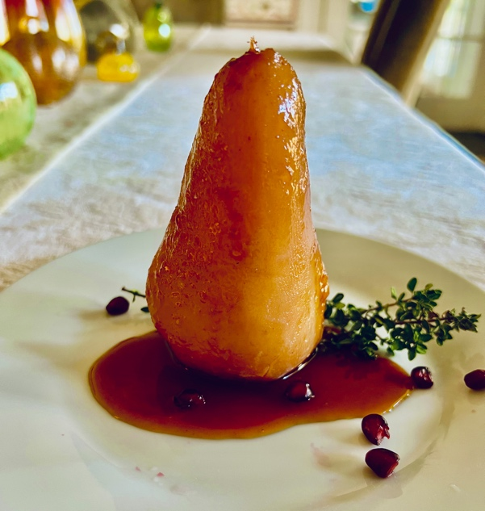
PREP: 10 MIN
INACTIVE: 30 MIN
COOK: 40 MIN
TOTAL: 1 HR 20 MIN

YIELD: 6 SERVINGS

INGREDIENTS
¾ bottle Sauvignon Blanc
¼ cup pomegranate juice
¼ cup GC Napa Valley Natural Guava Sugar
3 Tbsp GC Napa Valley Natural Orange Honey
(can substitute Lavender Honey)
¼ cup water
3 2” long pieces of organic fresh lemon rind
2 tsp. vanilla extract
1 pod cardamon- seeds only
6 small, ripe but firm pears- Anjou, Bartlett, or Bosc
Optional 1 pt. vanilla bean ice cream
Garnish: 1 Tbsp pomegranate seeds (arils)

TO PREPARE
- Peel pears with vegetable peeler
- In a saucepan large enough to hold all the pears, combine Sauvignon Blanc, Guava Sugar, pomegranate juice, water, lemon rind, and vanilla extract. Bring to a simmer, stirring occasionally, until the sugar has melted.
- Pound pod cardamon to crack open . Remove seeds and place into poaching liquid.
- Add the pears and simmer for 15 to 20 minutes, turning occasionally, until the pears are tender (pierce with fork to check). Carefully remove pears with slotted spoon from the liquid and set on plate to cool.
- Pour poaching liquid through a sieve set over a bowl to separate solids from the liquid. Return liquid to saucepan and cook over medium-high heat until liquid is reduced to a guava-pear syrup that coats the back of a wooden spoon, about 45 minutes. Let cool; store pears in an airtight container until ready to serve
TO SERVE
Place each pear upright on a desert plate and drizzle with the guava pear syrup. Sprinkle pomegranate seeds around pear for garnish. Optional: Add a scoop of vanilla bean ice cream. Serve immediately.

WINE PAIRING
2019 Pietro Family Cellars Sauvignon Blanc
SUGGESTION- To marry flavors between the wine and the pouched pear, twist rim of wine glass in Pomegranate Sugar. Carefully pour in wine.

SHOPPING LIST & ITEMS FROM YOUR PANTRY INCLUDING ITEMS FROM PREVIOUS SHIPMENT
Prefer organic, farmers market, garden grown, and GMO, hormone-antibiotic-nitrate free products
1 bottle Pietro Family Cellars Sauvignon Blanc
4 oz pomegranate juice or 2 fresh pomegranates to deseed and press for juice
1 lemon
vanilla extract
6 small, ripe but firm pears- Anjou, Bartlett, or Bosc
Optional 1 pt. vanilla bean ice cream and pomegranate seeds (arils)
GC Napa Valley Natural Orange Honey

GC NAPA VALLEY PRODUCTS IN CURRENT SHIPMENT
GC Napa Valley Natural Guava Sugar 4 oz pouch
GC Napa Valley Natural Culinary Lavender Honey 8 oz jar

